
EL-MEHDI Mohamed Middle School - Hessainia 2 - Bouinan - Blida
Time Allotted: 1 hour and 30 min (90 minutes)
Class: 1 M.S ………….
Full Name: ………….………….………….………….………….………….………….………….………….………….………….………….………….……….
First Term Exam
- WRITTEN COMPREHENSION: (12 PTS)
The Text:

Hi, I am Salih. On weekdays, I always go to school. First, I do my homework. After that, I read an interesting book. I never watch TV. But at weekends, I prefer riding my bike. I enjoy playing football and drawing, too. I love my daily routine!

TASK 1 : Read📖the text and tick ✓⃝ the correct answer. (3pts)
- The text is about …..
Salih's family. Salih's habits and preferences. Salih's school. Salih's house.

TASK 2 : Read📖the text and rearrange ↻ the following ideas according to the text. (3pts)
a) Salih's weekend preferences 1) ……………………………………..………………..…
b) Salih's introduction 2) ……………………………………..………………..…
c) Salih's weekday habits 3) ……………………………………..………………..…
TAKS 3 :Read📖 the text and write if the following statements are True (T) ✓ or False (F) ☓ . (3pts)

- Salih always watches TV on weekdays. ……………..……………..
- Salih reads books after homework. ……………..……………..
- Salih enjoys drawing at weekends. ……………..……………..
- Salih hates his routine. ……………..……………..
TAKS 4 : Match ⇄ each word with its correct = meaning. (3pts)
Words | Meanings
1. prefer | a) everyday / every week
2. always | b) like
3. Wake up | c) Get up

- …………..
- ……………
- ……………
- LANGUAGE MASTERY: (4 PTS)
TASK 1 : Circle ⠀⃝ the right ✓ word in brackets ( ) to get a meaningful text. (2pts)

Aïcha (is / are) a pupil. She always (revise / revises) her lessons. She (like / likes) reading and (draw / drawing).

TASK 2 : Classify ☰ the following sentences from the text in the chart. (2pts)
♡ Preferences ♡
………………………………………………………………………………………..………..…

I always go to school.
I prefer riding bike.
I never watch TV.
I enjoy playing football.
⟳ Habits ⟳
………………………………………………………………………………………….………………

- WRITTEN PRODUCTION: (4 PTS)
Situation: Your pen pal Salih wants to know about you.
Task: Write a message to Salih Introduce yourself and tell him about your habits⟳ and preferences♡.

Structure: Follow these cues to write the message.
Your Message
Hi, my name is

On weekdays, I

At weekends, I

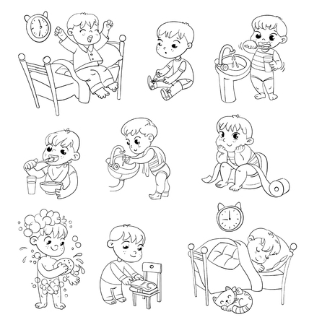




GOOD LUCK
DEAR PUPILS

Prepared by: Mr. Abdelmalek AISSAT
EL-MEHDI Mohamed Middle School - Hessainia 2 - Bouinan - Blida
Time Allotted: 1 hour and 30 min (90 minutes)
The Suggested Correction of
First Term Exam
- WRITTEN COMPREHENSION: (12 PTS)
The Text:

Hi, I am Salih. On weekdays, I always go to school. First, I do my homework. After that, I read an interesting book. I never watch TV. But at weekends, I prefer riding my bike. I enjoy playing football and drawing, too. I love my daily routine!

TASK 1 : Read📖the text and tick ✓⃝ the correct answer. (3pts)
- The text is about …..
Salih's family. Salih's habits and preferences. 3pt Salih's school. Salih's house.
TASK 2 : Read📖the text and rearrange ↻ the following ideas according to the text. (3pts)
a) Salih's weekend preferences 1) Salih's introduction 1pt
b) Salih's introduction 2) Salih's weekday habits 1pt
c) Salih's weekday habits 3) Salih's weekend preferences 1pt
TAKS 3 :Read📖 the text and write if the following statements are True (T) ✓ or False (F) ☓ . (3pts)
- Salih always watches TV on weekdays. False 0.75pt
- Salih reads books after homework. True 0.75pt
- Salih enjoys drawing at weekends. True 0.75pt
- Salih hates his routine. False 0.75pt
TAKS 4 : Match ⇄ each word with its correct = meaning. (3pts)
Words | Meanings
1. prefer | a) everyday / every week
2. always | b) like
3. Wake up | c) Get up

- b 1pt
- a 1pt
- c 1pt
- LANGUAGE MASTERY: (4 PTS)
TASK 1 : Circle ⠀⃝ the right ✓ word in brackets ( ) to get a meaningful text. (2pts)
Aïcha ( is / are) 0.5pt a pupil. She always (revise / revises ) 0.5pt her lessons. She ( like / likes ) 0.5pt reading and ( draw / drawing ). 0.5pt 0.5pt

TASK 2 : Classify ☰ the following sentences from the text in the chart. (2pts)
♡ Preferences ♡
I prefer riding bike. 0.5pt
I enjoy playing football. 0.5pt

I always go to school.
I prefer riding bike.
I never watch TV.
I enjoy playing football.
⟳ Habits ⟳
I always go to school. 0.5pt
I never watch TV. 0.5pt
…

- WRITTEN PRODUCTION: (4 PTS)
Situation: Your pen pal Salih wants to know about you.
Task: Write a message to Salih Introduce yourself and tell him about your habits⟳ and preferences♡.
Structure: Follow these cues to write the message.
Your Message
Hi, my name is Basil. I’m 11 years old. I’m from Syria and I live in Bouinan. I’m a pupil at MEHDI Mohamed middle school. On weekdays, I always wakeup at 7 o’clock. After that, I pray and I eat breakfast. Then, I go to school with my brother Bashar. We prefer riding bikes. At weekends, I enjoy reciting Quran but I don’t like watching TV. My friend Yazid loves reading books. I like reading stories too, it’s fun.

GOOD LUCK
DEAR PUPILS

Prepared by: Mr. Abdelmalek AISSAT

