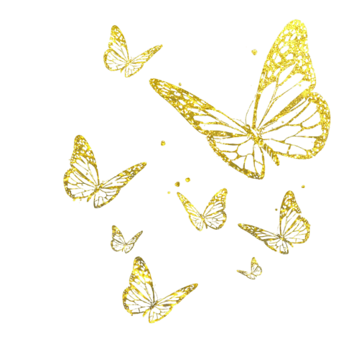
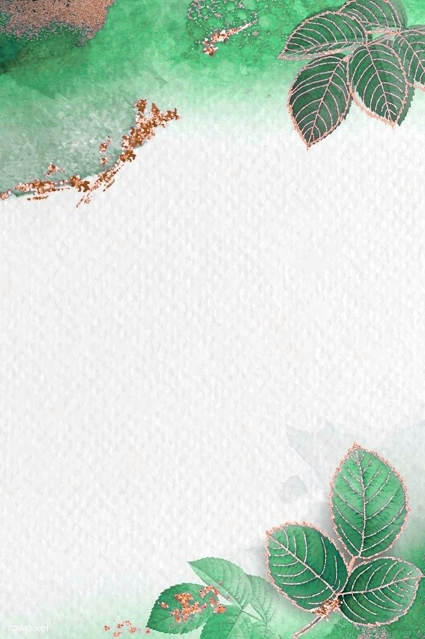
People ‘s Democratic Republic of Algeria
Ministy of National Education

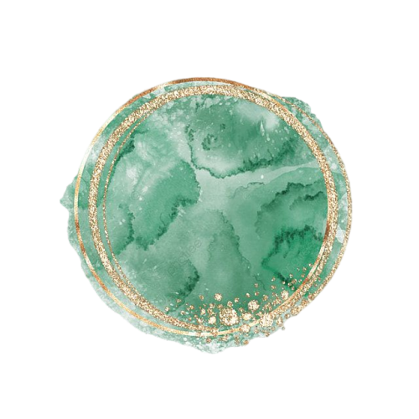

Teacher :………………….

School Year :
2025 -2026

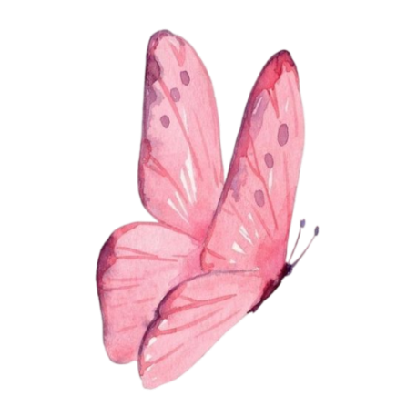
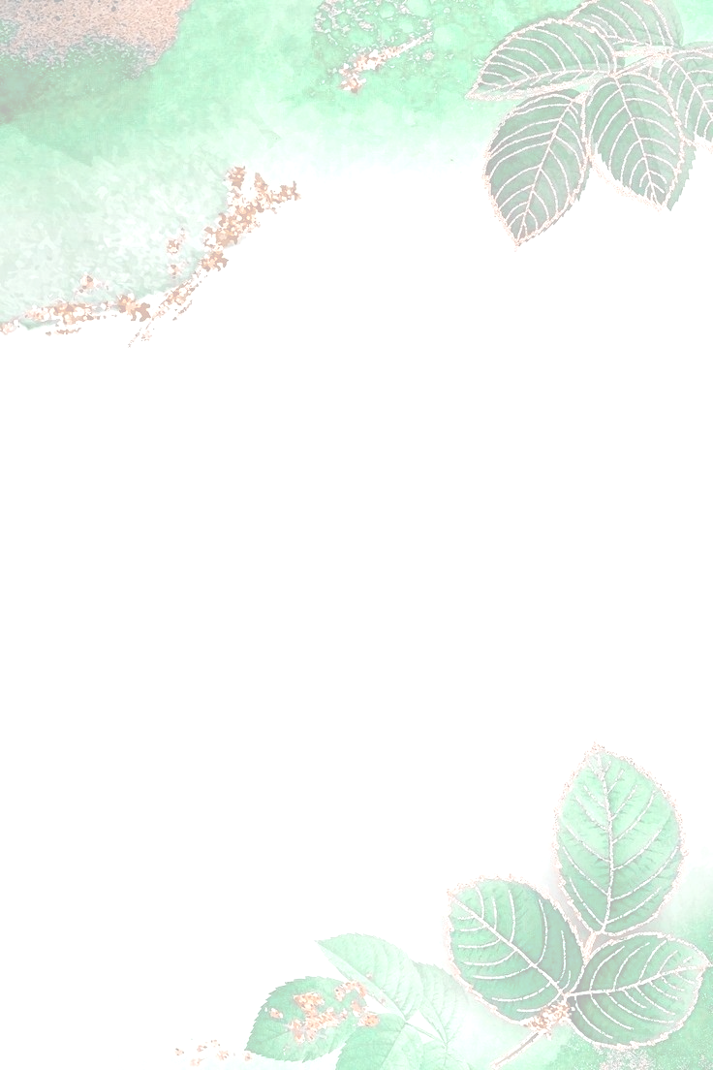
TEACHER’S INFORMATION

First name:.
Family name:.
Date and place of birth :
Address: :
Phone number :
E-mail Address :
Current School :



4PS

3PS

First Term

5PS

Second Term

Third Term


Class : ………………………………………………………

Boys :
Girls :



Special Cases

Class : ………………………………………………………
Average |  |  | Exam |  |  |  |  |  |  |  |  |  |  |  |  |  | Student  Name |  |  |  |  |  |  | N
 |  |  |  |  |  |  |  |  |  |  |  |  |  |  |  |  |  |  |  |  |  |  |  | 01
 |  |  |  |  |  |  |  |  |  |  |  |  |  |  |  |  |  |  |  |  |  |  |  | 02
 |  |  |  |  |  |  |  |  |  |  |  |  |  |  |  |  |  |  |  |  |  |  |  | 03
 |  |  |  |  |  |  |  |  |  |  |  |  |  |  |  |  |  |  |  |  |  |  |  | 04
 |  |  |  |  |  |  |  |  |  |  |  |  |  |  |  |  |  |  |  |  |  |  |  | 05
 |  |  |  |  |  |  |  |  |  |  |  |  |  |  |  |  |  |  |  |  |  |  |  | 06
 |  |  |  |  |  |  |  |  |  |  |  |  |  |  |  |  |  |  |  |  |  |  |  | 07
 |  |  |  |  |  |  |  |  |  |  |  |  |  |  |  |  |  |  |  |  |  |  |  | 08
 |  |  |  |  |  |  |  |  |  |  |  |  |  |  |  |  |  |  |  |  |  |  |  | 09
 |  |  |  |  |  |  |  |  |  |  |  |  |  |  |  |  |  |  |  |  |  |  |  | 10
 |  |  |  |  |  |  |  |  |  |  |  |  |  |  |  |  |  |  |  |  |  |  |  | 11
 |  |  |  |  |  |  |  |  |  |  |  |  |  |  |  |  |  |  |  |  |  |  |  | 12
 |  |  |  |  |  |  |  |  |  |  |  |  |  |  |  |  |  |  |  |  |  |  |  | 13
 |  |  |  |  |  |  |  |  |  |  |  |  |  |  |  |  |  |  |  |  |  |  |  | 14
 |  |  |  |  |  |  |  |  |  |  |  |  |  |  |  |  |  |  |  |  |  |  |  | 15
 |  |  |  |  |  |  |  |  |  |  |  |  |  |  |  |  |  |  |  |  |  |  |  | 16
 |  |  |  |  |  |  |  |  |  |  |  |  |  |  |  |  |  |  |  |  |  |  |  | 17
 |  |  |  |  |  |  |  |  |  |  |  |  |  |  |  |  |  |  |  |  |  |  |  | 18
 |  |  |  |  |  |  |  |  |  |  |  |  |  |  |  |  |  |  |  |  |  |  |  | 19
 |  |  |  |  |  |  |  |  |  |  |  |  |  |  |  |  |  |  |  |  |  |  |  | 20
 |  |  |  |  |  |  |  |  |  |  |  |  |  |  |  |  |  |  |  |  |  |  |  | 21
 |  |  |  |  |  |  |  |  |  |  |  |  |  |  |  |  |  |  |  |  |  |  |  | 22
 |  |  |  |  |  |  |  |  |  |  |  |  |  |  |  |  |  |  |  |  |  |  |  | 23
 |  |  |  |  |  |  |  |  |  |  |  |  |  |  |  |  |  |  |  |  |  |  |  | 24
 |  |  |  |  |  |  |  |  |  |  |  |  |  |  |  |  |  |  |  |  |  |  |  | 25
 |  |  |  |  |  |  |  |  |  |  |  |  |  |  |  |  |  |  |  |  |  |  |  | 26
 |  |  |  |  |  |  |  |  |  |  |  |  |  |  |  |  |  |  |  |  |  |  |  | 27
 |  |  |  |  |  |  |  |  |  |  |  |  |  |  |  |  |  |  |  |  |  |  |  | 28
 |  |  |  |  |  |  |  |  |  |  |  |  |  |  |  |  |  |  |  |  |  |  |  | 29
 |  |  |  |  |  |  |  |  |  |  |  |  |  |  |  |  |  |  |  |  |  |  |  | 30
 |  |  |  |  |  |  |  |  |  |  |  |  |  |  |  |  |  |  |  |  |  |  |  | 31
 |  |  |  |  |  |  |  |  |  |  |  |  |  |  |  |  |  |  |  |  |  |  |  | 32
 |  |  |  |  |  |  |  |  |  |  |  |  |  |  |  |  |  |  |  |  |  |  |  | 33
 |  |  |  |  |  |  |  |  |  |  |  |  |  |  |  |  |  |  |  |  |  |  |  | 34
 |  |  |  |  |  |  |  |  |  |  |  |  |  |  |  |  |  |  |  |  |  |  |  | 35
 |  |  |  |  |  |  |  |  |  |  |  |  |  |  |  |  |  |  |  |  |  |  |  | 36
 |  |  |  |  |  |  |  |  |  |  |  |  |  |  |  |  |  |  |  |  |  |  |  | 37
 |  |  |  |  |  |  |  |  |  |  |  |  |  |  |  |  |  |  |  |  |  |  |  | 38
 |  |  |  |  |  |  |  |  |  |  |  |  |  |  |  |  |  |  |  |  |  |  |  | 39
 |  |  |  |  |  |  |  |  |  |  |  |  |  |  |  |  |  |  |  |  |  |  |  | 40
Reading Comprehenion |  |  |  |  |  |  |  |  |  | Oral Interaction |  |  |  |  |  |  |  |  |  |  |  | Class : ………….
Respect the pace  Of reading |  | Use intonation  appropriately |  | Use punctuation  marks accuraly | Read sentences |  | Relate the grapheme to the phoneme |  |  | Use the paralinguistic features to interact orally |  | Use the appropriate language to interact orally | Use the appropriate langage to interact orally |  |  | Respond to the instruction |  | Recognize the general idea |  |  | Demonstrate interest in the topic when listening
 |  |  |  |  |  |  |  |  |  |  |  |  |  |  |  |  |  |  |  |  |  | Student  Name |  |  | N
 |  |  |  |  |  |  |  |  |  |  |  |  |  |  |  |  |  |  |  |  |  |  |  |  | 01
 |  |  |  |  |  |  |  |  |  |  |  |  |  |  |  |  |  |  |  |  |  |  |  |  | 02
 |  |  |  |  |  |  |  |  |  |  |  |  |  |  |  |  |  |  |  |  |  |  |  |  | 03
 |  |  |  |  |  |  |  |  |  |  |  |  |  |  |  |  |  |  |  |  |  |  |  |  | 04
 |  |  |  |  |  |  |  |  |  |  |  |  |  |  |  |  |  |  |  |  |  |  |  |  | 05
 |  |  |  |  |  |  |  |  |  |  |  |  |  |  |  |  |  |  |  |  |  |  |  |  | 06
 |  |  |  |  |  |  |  |  |  |  |  |  |  |  |  |  |  |  |  |  |  |  |  |  | 07
 |  |  |  |  |  |  |  |  |  |  |  |  |  |  |  |  |  |  |  |  |  |  |  |  | 08
 |  |  |  |  |  |  |  |  |  |  |  |  |  |  |  |  |  |  |  |  |  |  |  |  | 09
 |  |  |  |  |  |  |  |  |  |  |  |  |  |  |  |  |  |  |  |  |  |  |  |  | 10
 |  |  |  |  |  |  |  |  |  |  |  |  |  |  |  |  |  |  |  |  |  |  |  |  | 11
 |  |  |  |  |  |  |  |  |  |  |  |  |  |  |  |  |  |  |  |  |  |  |  |  | 12
 |  |  |  |  |  |  |  |  |  |  |  |  |  |  |  |  |  |  |  |  |  |  |  |  | 13
 |  |  |  |  |  |  |  |  |  |  |  |  |  |  |  |  |  |  |  |  |  |  |  |  | 14
 |  |  |  |  |  |  |  |  |  |  |  |  |  |  |  |  |  |  |  |  |  |  |  |  | 15
 |  |  |  |  |  |  |  |  |  |  |  |  |  |  |  |  |  |  |  |  |  |  |  |  | 16
 |  |  |  |  |  |  |  |  |  |  |  |  |  |  |  |  |  |  |  |  |  |  |  |  | 17
 |  |  |  |  |  |  |  |  |  |  |  |  |  |  |  |  |  |  |  |  |  |  |  |  | 18
 |  |  |  |  |  |  |  |  |  |  |  |  |  |  |  |  |  |  |  |  |  |  |  |  | 19
 |  |  |  |  |  |  |  |  |  |  |  |  |  |  |  |  |  |  |  |  |  |  |  |  | 20
 |  |  |  |  |  |  |  |  |  |  |  |  |  |  |  |  |  |  |  |  |  |  |  |  | 21
 |  |  |  |  |  |  |  |  |  |  |  |  |  |  |  |  |  |  |  |  |  |  |  |  | 22
 |  |  |  |  |  |  |  |  |  |  |  |  |  |  |  |  |  |  |  |  |  |  |  |  | 23
 |  |  |  |  |  |  |  |  |  |  |  |  |  |  |  |  |  |  |  |  |  |  |  |  | 24
 |  |  |  |  |  |  |  |  |  |  |  |  |  |  |  |  |  |  |  |  |  |  |  |  | 25
 |  |  |  |  |  |  |  |  |  |  |  |  |  |  |  |  |  |  |  |  |  |  |  |  | 26
 |  |  |  |  |  |  |  |  |  |  |  |  |  |  |  |  |  |  |  |  |  |  |  |  | 27
 |  |  |  |  |  |  |  |  |  |  |  |  |  |  |  |  |  |  |  |  |  |  |  |  | 28
 |  |  |  |  |  |  |  |  |  |  |  |  |  |  |  |  |  |  |  |  |  |  |  |  | 29
 |  |  |  |  |  |  |  |  |  |  |  |  |  |  |  |  |  |  |  |  |  |  |  |  | 30
 |  |  |  |  |  |  |  |  |  |  |  |  |  |  |  |  |  |  |  |  |  |  |  |  | 31
 |  |  |  |  |  |  |  |  |  |  |  |  |  |  |  |  |  |  |  |  |  |  |  |  | 32
 |  |  |  |  |  |  |  |  |  |  |  |  |  |  |  |  |  |  |  |  |  |  |  |  | 33
 |  |  |  |  |  |  |  |  |  |  |  |  |  |  |  |  |  |  |  |  |  |  |  |  | 34
 |  |  |  |  |  |  |  |  |  |  |  |  |  |  |  |  |  |  |  |  |  |  |  |  | 35
 |  |  |  |  |  |  |  |  |  |  |  |  |  |  |  |  |  |  |  |  |  |  |  |  | 36
 |  |  |  |  |  |  |  |  |  |  |  |  |  |  |  |  |  |  |  |  |  |  |  |  | 37
 |  |  |  |  |  |  |  |  |  |  |  |  |  |  |  |  |  |  |  |  |  |  |  |  | 38
 |  |  |  |  |  |  |  |  |  |  |  |  |  |  |  |  |  |  |  |  |  |  |  |  | 39
 |  |  |  |  |  |  |  |  |  |  |  |  |  |  |  |  |  |  |  |  |  |  |  |  | 40
Written production |  |  |  |  |  |  |  |  |  |  |  | Reading comprehensin
Keey the paper neat | Use punctuation  Where necessary |  |  | Apply the sentence  Structure correctly | Transfer given notes  Into a written  paragraph |  |  |  | Respond to the  instruction |  |  | Recognize the  Structuer of the instruction |  |  | Recognize some specific  Information in the text |  |  |  |  | Recognize the general  Idea of the text
 |  |  |  |  |  |  |  |  |  |  |  |  |  |  |  |  |  |  |  |  |  |  | Student  Name |  | N
 |  |  |  |  |  |  |  |  |  |  |  |  |  |  |  |  |  |  |  |  |  |  |  |  | 01
 |  |  |  |  |  |  |  |  |  |  |  |  |  |  |  |  |  |  |  |  |  |  |  |  | 02
 |  |  |  |  |  |  |  |  |  |  |  |  |  |  |  |  |  |  |  |  |  |  |  |  | 03
 |  |  |  |  |  |  |  |  |  |  |  |  |  |  |  |  |  |  |  |  |  |  |  |  | 04
 |  |  |  |  |  |  |  |  |  |  |  |  |  |  |  |  |  |  |  |  |  |  |  |  | 05
 |  |  |  |  |  |  |  |  |  |  |  |  |  |  |  |  |  |  |  |  |  |  |  |  | 06
 |  |  |  |  |  |  |  |  |  |  |  |  |  |  |  |  |  |  |  |  |  |  |  |  | 07
 |  |  |  |  |  |  |  |  |  |  |  |  |  |  |  |  |  |  |  |  |  |  |  |  | 08
 |  |  |  |  |  |  |  |  |  |  |  |  |  |  |  |  |  |  |  |  |  |  |  |  | 09
 |  |  |  |  |  |  |  |  |  |  |  |  |  |  |  |  |  |  |  |  |  |  |  |  | 10
 |  |  |  |  |  |  |  |  |  |  |  |  |  |  |  |  |  |  |  |  |  |  |  |  | 11
 |  |  |  |  |  |  |  |  |  |  |  |  |  |  |  |  |  |  |  |  |  |  |  |  | 12
 |  |  |  |  |  |  |  |  |  |  |  |  |  |  |  |  |  |  |  |  |  |  |  |  | 13
 |  |  |  |  |  |  |  |  |  |  |  |  |  |  |  |  |  |  |  |  |  |  |  |  | 14
 |  |  |  |  |  |  |  |  |  |  |  |  |  |  |  |  |  |  |  |  |  |  |  |  | 15
 |  |  |  |  |  |  |  |  |  |  |  |  |  |  |  |  |  |  |  |  |  |  |  |  | 16
 |  |  |  |  |  |  |  |  |  |  |  |  |  |  |  |  |  |  |  |  |  |  |  |  | 17
 |  |  |  |  |  |  |  |  |  |  |  |  |  |  |  |  |  |  |  |  |  |  |  |  | 18
 |  |  |  |  |  |  |  |  |  |  |  |  |  |  |  |  |  |  |  |  |  |  |  |  | 19
 |  |  |  |  |  |  |  |  |  |  |  |  |  |  |  |  |  |  |  |  |  |  |  |  | 20
 |  |  |  |  |  |  |  |  |  |  |  |  |  |  |  |  |  |  |  |  |  |  |  |  | 21
 |  |  |  |  |  |  |  |  |  |  |  |  |  |  |  |  |  |  |  |  |  |  |  |  | 22
 |  |  |  |  |  |  |  |  |  |  |  |  |  |  |  |  |  |  |  |  |  |  |  |  | 23
 |  |  |  |  |  |  |  |  |  |  |  |  |  |  |  |  |  |  |  |  |  |  |  |  | 24
 |  |  |  |  |  |  |  |  |  |  |  |  |  |  |  |  |  |  |  |  |  |  |  |  | 25
 |  |  |  |  |  |  |  |  |  |  |  |  |  |  |  |  |  |  |  |  |  |  |  |  | 26
 |  |  |  |  |  |  |  |  |  |  |  |  |  |  |  |  |  |  |  |  |  |  |  |  | 27
 |  |  |  |  |  |  |  |  |  |  |  |  |  |  |  |  |  |  |  |  |  |  |  |  | 28
 |  |  |  |  |  |  |  |  |  |  |  |  |  |  |  |  |  |  |  |  |  |  |  |  | 29
 |  |  |  |  |  |  |  |  |  |  |  |  |  |  |  |  |  |  |  |  |  |  |  |  | 30
 |  |  |  |  |  |  |  |  |  |  |  |  |  |  |  |  |  |  |  |  |  |  |  |  | 31
 |  |  |  |  |  |  |  |  |  |  |  |  |  |  |  |  |  |  |  |  |  |  |  |  | 32
 |  |  |  |  |  |  |  |  |  |  |  |  |  |  |  |  |  |  |  |  |  |  |  |  | 33
 |  |  |  |  |  |  |  |  |  |  |  |  |  |  |  |  |  |  |  |  |  |  |  |  | 34
 |  |  |  |  |  |  |  |  |  |  |  |  |  |  |  |  |  |  |  |  |  |  |  |  | 35
 |  |  |  |  |  |  |  |  |  |  |  |  |  |  |  |  |  |  |  |  |  |  |  |  | 36
 |  |  |  |  |  |  |  |  |  |  |  |  |  |  |  |  |  |  |  |  |  |  |  |  | 37
 |  |  |  |  |  |  |  |  |  |  |  |  |  |  |  |  |  |  |  |  |  |  |  |  | 38
 |  |  |  |  |  |  |  |  |  |  |  |  |  |  |  |  |  |  |  |  |  |  |  |  | 39
 |  |  |  |  |  |  |  |  |  |  |  |  |  |  |  |  |  |  |  |  |  |  |  |  | 40

