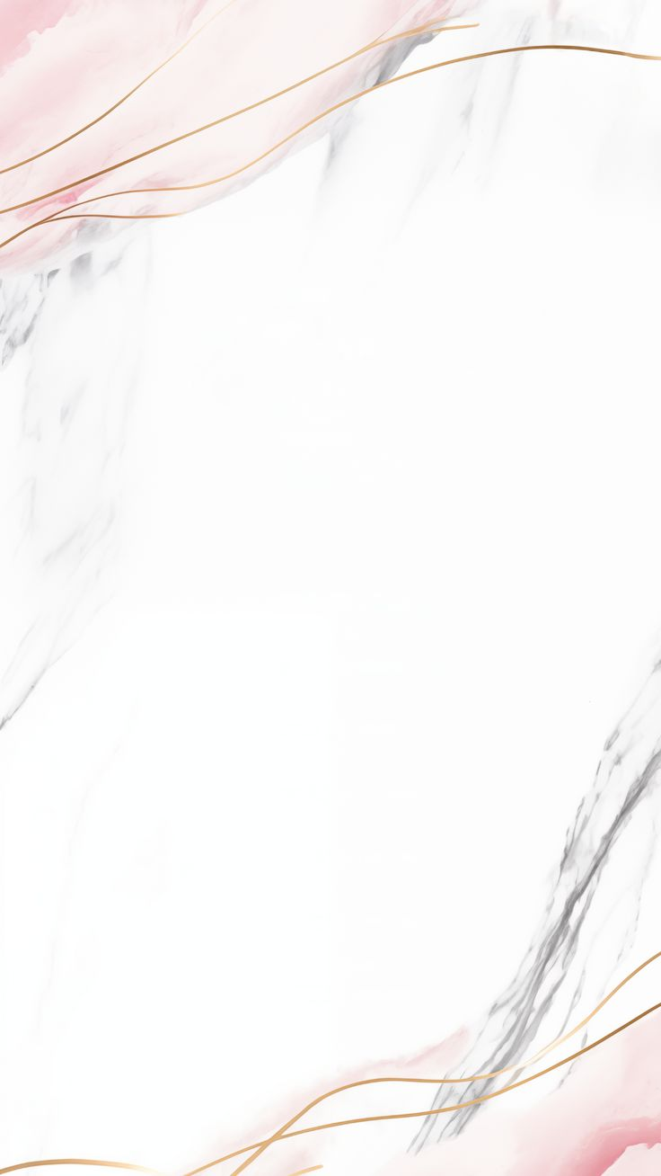
People ‘s Democratic Republic of Algeria
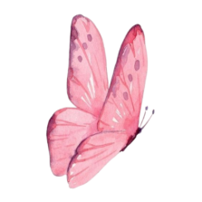
Ministy of National Education
SCHOOL YEAR : 2025 -2026 EDUCATION AUTHORITY :
LEVEL : 5 Ps SCHOOL :

TEACHER :


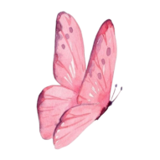




TEACHER HEADMASTER INSPECTOR

People ‘s Democratic Republic of Algeria
Ministy of National Education
SCHOOL YEAR : 2025 -2026 EDUCATION AUTHORITY :
LEVEL : 5 Ps SCHOOL :

TEACHER :

2
Hometown
& Directions

1 Jobs occupations & Habbies

3
Hollidays
& Travelling

TEACHER HEADMASTER INSPECTOR

People ‘s Democratic Republic of Algeria
Ministy of National Education
SCHOOL YEAR : 2025 -2026 EDUCATION AUTHORITY :
LEVEL : 5 Ps SCHOOL :

TEACHER :






YEAERS | MALE | FEMALE

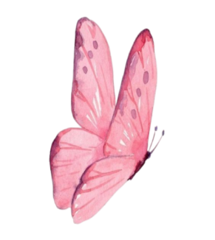

TEACHER HEADMASTER INSPECTOR

People ‘s Democratic Republic of Algeria
Ministy of National Education
SCHOOL YEAR : 2025 -2026 EDUCATION AUTHORITY :
LEVEL :5 Ps SCHOOL :

TEACHER :

Sequence 3
* WE ALL GO TRAVELLING BY
* LET’S PUT SOME HA!HA!HA
Sequence 2
* OUR TOWN
* TWINKLE . TWINKLE
Sequence 1
*WHAT DO YOU WANT TO BE
* MY HOBBY



TEACHER HEADMASTER INSPECTOR

People ‘s Democratic Republic of Algeria
Ministy of National Education
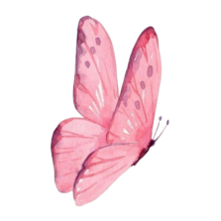
SCHOOL YEAR : 2025 -2026 EDUCATION AUTHORITY :
LEVEL : 5Ps SCHOOL :

TEACHER :

Sunday
Monday
Tuesday
Wednesday
Thursday
Notes
TEACHER HEADMASTER INSPECTOR

People ‘s Democratic Republic of Algeria

Ministy of National Education
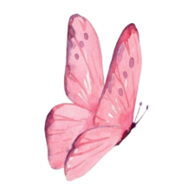
SCHOOL YEAR : 2025 -2026 EDUCATION AUTHORITY .
LEVEL : 5 Ps SCHOOL :
TEACHER :

N | PUPIL’S NAME | N | PUPIL’S NAME

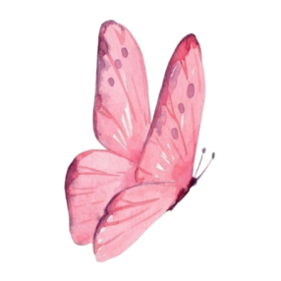
TEACHER HEADMASTER INSPECTOR

