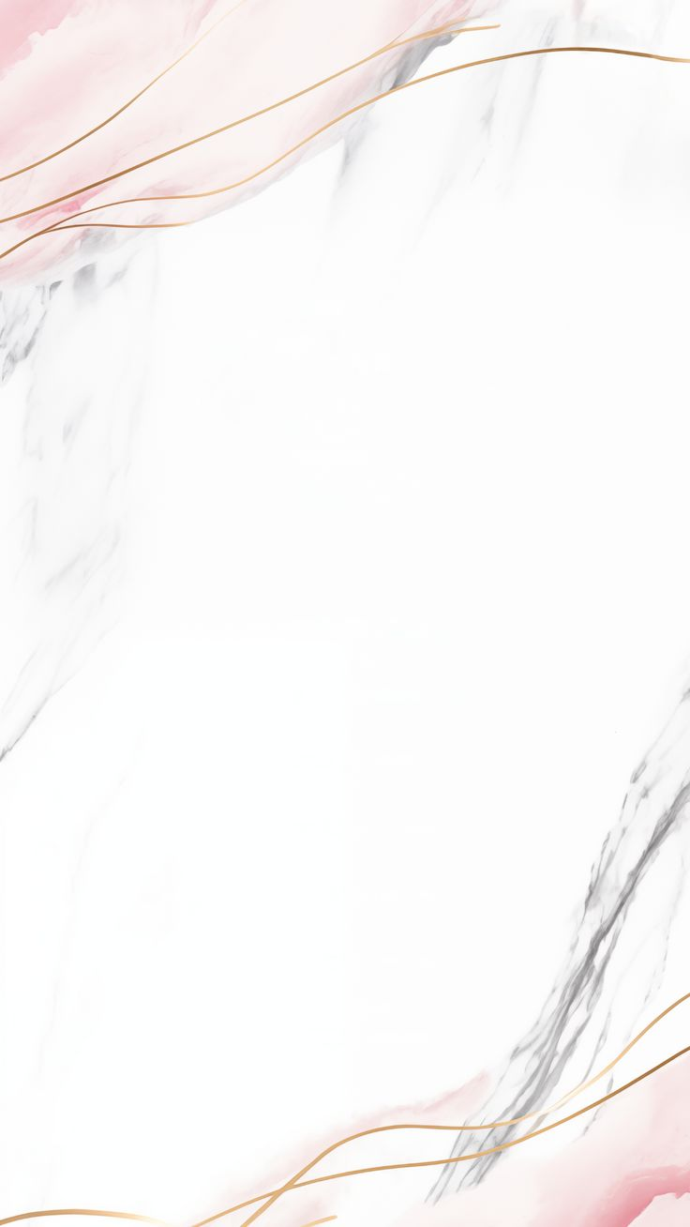
People ‘s Democratic Republic of Algeria
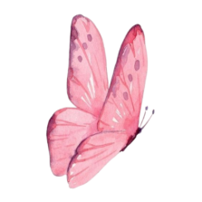
Ministy of National Education
SCHOOL YEAR : 2025 -2026 EDUCATION AUTHORITY :
LEVEL : 4 Ps SCHOOL :

TEACHER :

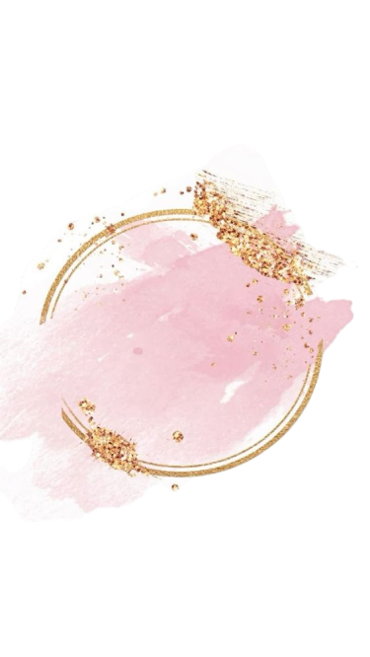
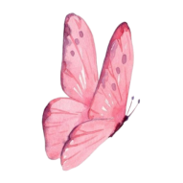

3 Fun Time and Games
Design a mini dictionary some fun activities and games
2 School
Draw a school plan contains the main facilities
1 Family & Frinds
Design a mini dictionary extend family members jobs



5 Animals
Design a mini dictionary about some animals
4 Food and Health
Design a mini dictionary about food

TEACHER HEADMASTER INSPECTOR

People ‘s Democratic Republic of Algeria
Ministy of National Education
SCHOOL YEAR : 2025 -2026 EDUCATION AUTHORITY :
LEVEL : 4 Ps SCHOOL :

TEACHER :

3 Fun Time and Games

1 Family & Frinds
2 School

5 Animals

4 Food and Health

TEACHER HEADMASTER INSPECTOR

People ‘s Democratic Republic of Algeria
Ministy of National Education
SCHOOL YEAR : 2025 -2026 EDUCATION AUTHORITY :
LEVEL : 4 Ps SCHOOL :

TEACHER :

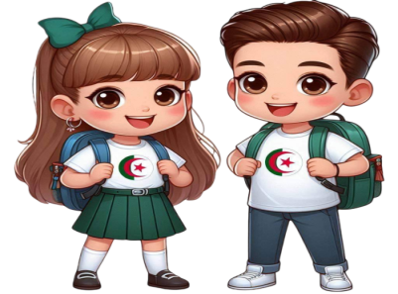

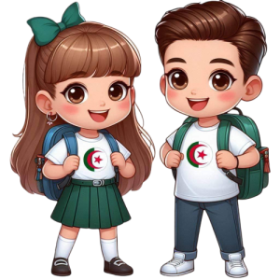


YEAERS | MALE | FEMALE

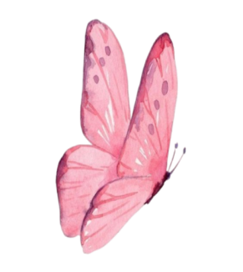

TEACHER HEADMASTER INSPECTOR

People ‘s Democratic Republic of Algeria
Ministy of National Education
SCHOOL YEAR : 2025 -2026 EDUCATION AUTHORITY :
LEVEL :4 Ps SCHOOL :

TEACHER :

Sequence 3
HIDE AND SEEK

Sequence 1
DADDY
FINGER
Sequence 2
I LOVE MY SCHOOL

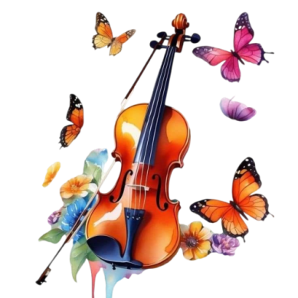



Sequence 5
BABA BLACK SHEEP

Sequence 4
HEAL THY FOOD
SICK LITTLE BABY

TEACHER HEADMASTER INSPECTOR

People ‘s Democratic Republic of Algeria
Ministy of National Education
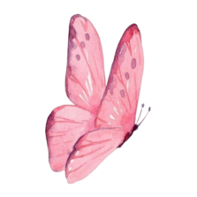
SCHOOL YEAR : 2025 -2026 EDUCATION AUTHORITY :
LEVEL : 4Ps SCHOOL :

TEACHER :

Sunday
Monday
Tuesday
Wednesday
Thursday
Notes
TEACHER HEADMASTER INSPECTOR

People ‘s Democratic Republic of Algeria

Ministy of National Education
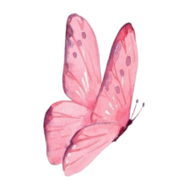
SCHOOL YEAR : 2025 -2026 EDUCATION AUTHORITY .
LEVEL : 4 Ps SCHOOL :
TEACHER :

N | PUPIL’S NAME | N | PUPIL’S NAME

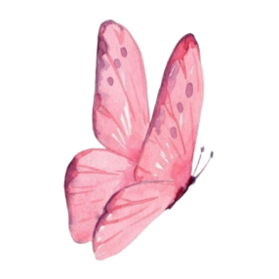
TEACHER HEADMASTER INSPECTOR

