Mohammed Takefi Middle School School year: 2023/2024
English Catching Up Exam
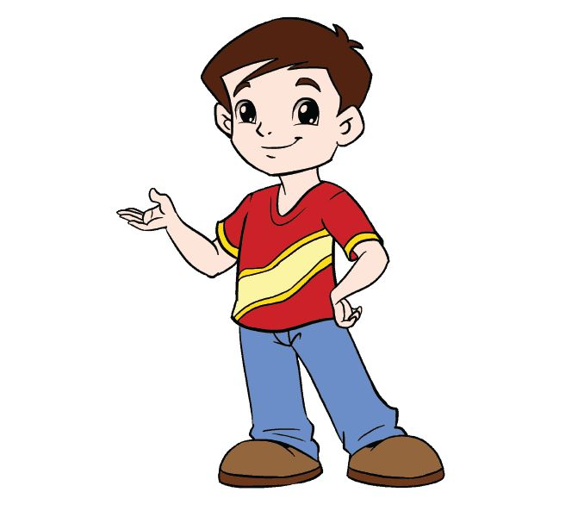
Text
Hello , my name is Peter . I am 11 years old . I am from Australia and I live in Sydney . I am a pupil at Junior Middle School, it is very beautiful . My friend Jhon is 12 years old . He is from Great Britain .
How about you ?

Part one:
Reading Comprehension: (7pts)
Activity 01: Read the text and fill in Peter’s profile: (3pts)
Name : ........................ .......
Age : ...................................
Country : ...................... .....
City : ...................................
School : ..............................
Occupation: ……………………………………...

Activity 02 : Answer by ‘true’ or ‘false’ : (3pts)
1- Peter is a teacher. (………...............)
2- John is 11 years old. (.......................)
3- Peter is from Great Britain. (.......................)
Activity 03 : Find in the text the synonyms of the following words (2pts)
1) Hi = ....................... 2) Nice = ……....................

Mastery of Language: (7pts)
Activity 01 : Replace the underlined words with the appropriate personal pronoun ( she- he- they) (3pts)
1) Jhon is from Great Britain . => ...........................is from Great Britain.
2) John and Peter are friends . =>...........................are friends .
3) Chaima is Algerian . =>...........................is Algerian .
Activity 02 : Circle the right auxiliary (2pts)
1. Sami ( am – is ) a pupil at Ben Boulaid middle school . He ( is – are ) from Morocco .
2. Sonia and I ( is - are) sisters .
3. You and Mary ( is - are ) 13 years old .
Activity 03 : Classify the following words in the table (3pts)
Five - play - Nice - Game
/ ei / | / ai /
-………………………………  -……………………………… | -…………………………….  -…………………………….

Situation of integration: (6pts)
You have a new friend who wants to know more about you. Complete the following passage to finish writing a short paragraph introducing yourself to your friend.
Dear new friend,
I am very happy to be your new friend. My name is……………………………………… I am…………………………………………..I am a …………………………….at Mouhamed Tekfi Middle School. I am from ………………………………………and I ………………………….in ……………………………………….
My father is an ……………………………….and my mother is……………………………………..
Yours
………………………………..


Good luck.

