People’s Democratic Republic of Algeria
Houch El Mihoub-3- Middle School
Level : 3MS Timming : 1h 30 min
First Term Exam
Text:
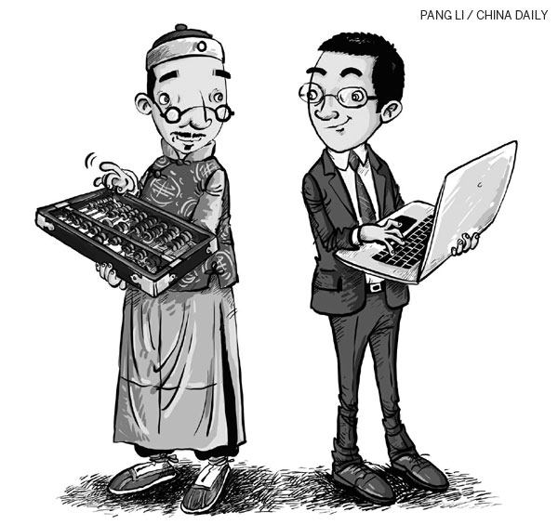
Life nowadays is very different from how it was in the past. Various aspects including; lifestyle, dwelling, education and entertainment, has changed over the years.
In the past, life was difficult. People used to live in houses made of clay, muds, bricks and wood. They used to wear handmade clothes like ‘El Hayek’, ‘Jebba’, ‘Barnouss’……etc. Kids used to spend more time with their friends, playing simple games like hopscotch and skipping rope, using simple or handmade toys like marbles or rag dolls. Their food consisted of ingredients grown in a field or animals raised in their farms and they only ate homemade meals like ‘Chakhchoukha’, ‘Kesra’, ‘Mhajeb’…….etc
In the present, we live in comfortable houses with many appliances like a fridge, TV set, computers and other machines. Our children play now with video games and are not interested in playing outside anymore. In addition, our food is now all fast food like pizzas and burgers and we rarely wear traditional clothes; only in weddings or special occasions.

Part one
A/Reading Comprehension
Activity 01: Read the text and say ‘True’ or ‘False’ (03pts)
- Life in the past was difficult. (…………………….)
- In the past people used to eat fast food. (……………………..)
- Nowadays children play video games. (……………………..)
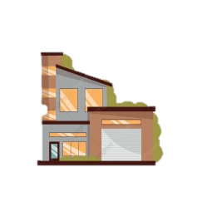
Activity 02: Read the text again and fill in the table with two items in each column (02pts)
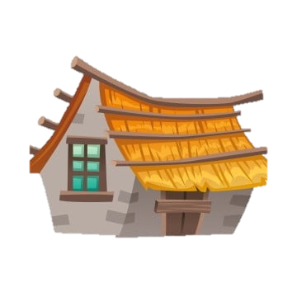  In the past | In the present
- ……………….  - ………………. | - ……………….  - ……………….

Activity 03: Match each word with its opposite (02pts)
Inside - - Modern
Old - - Easy
Past - - Outside
Difficult - - Present

B/Mastery of Language
Activity 01: Supply the correct punctuation and capitalization (03pts)
Tin the past children used to play with marbles and rag dolls. now, they play video games
Activity 02: Put the verbs in the correct form of the past simple (02pts)
Transportation in the past ……………..... ( to be ) difficult. People ……………………. ( not / to travel ) using cars, they …………………… ( to like ) walking to their destination.
Activity 03: Classify the words according to the pronunciation of their final ‘-ed’: (02pts)
Visited - Moved - Finished - Blamed
/ t / | / d / | / id /
- | -  - | -

Part two
Situation of Integration: (06pts)
You and your best friend are participating in a school magazine contest and you were asked to prepare an interview to talk about your life. Complete the following interview to win the first prize.

You: What primary school did you use to go to?
Your best friend: ……………………………………………..
You: Did you use to go to school by car?
Your BF: …………………………………………………….
You: …………………………………………………………?
Your BF: I used to play football outside with my friends.
You: ………………………………………………………...?
Your BF: I used to wake up at 7:00.
You: How often do you help your mother with chores?
Your BF: ………………………………………………..…...
You: Do you like helping her?
Your BF: ……………………………………………..……..


Good Luck

