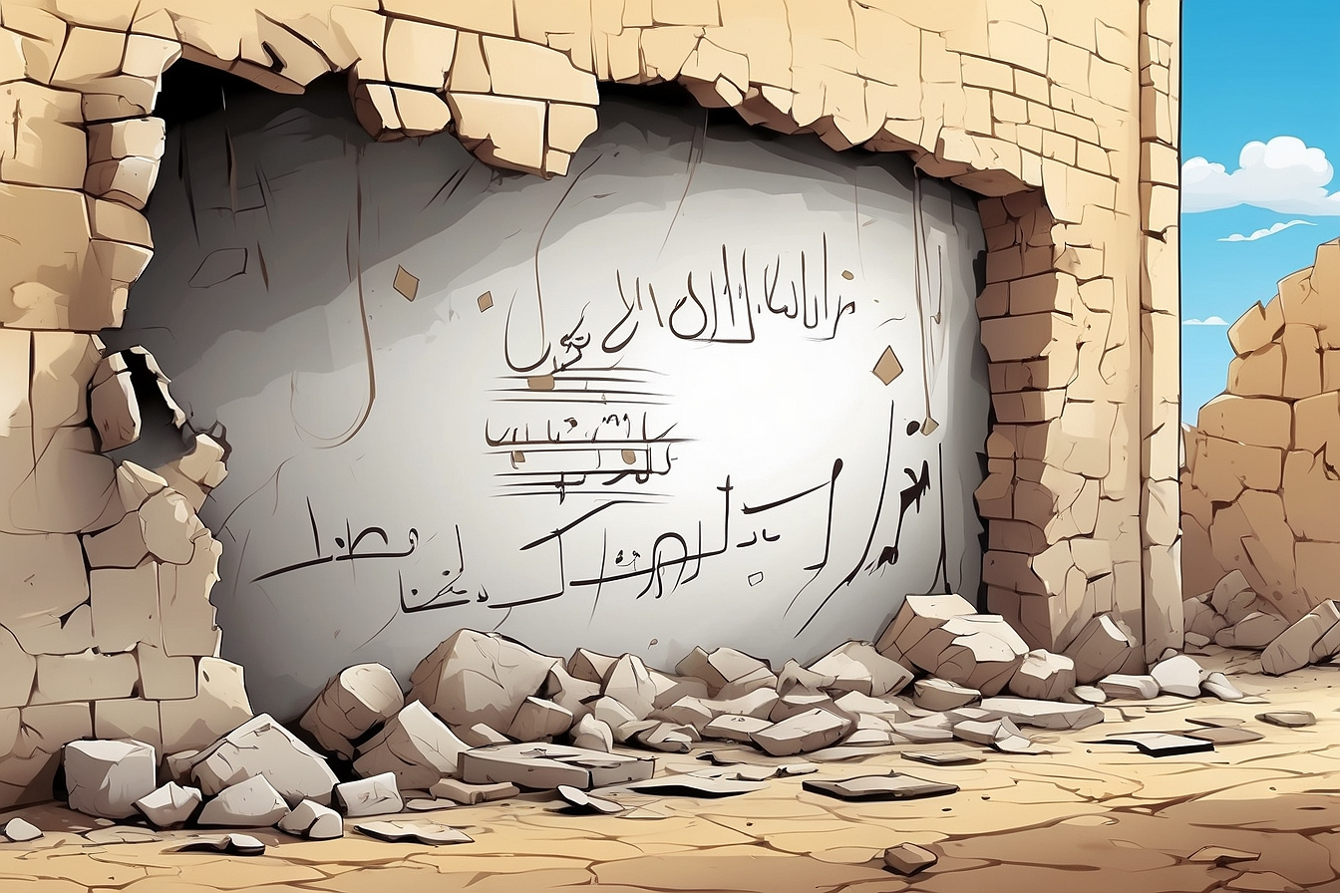


A
The First Term Test
Full Name :……………….
Class :4MS……………….


Harun al-Rashid was born on March 17th, 763 in Rey, near Tahran, Iran. He was the son of al-Mahdi, who the third Abbasid Caliph (ruled 775 – 786). Most of his time was dedicated to mastering Hadith and Quran. In addition, he underwent advanced physical education as a future mujahid and therefore he practised swordplay, archery and learnt the art of war. At the age of 18, a few years before becoming Caliph, Harun married his cousin Amat al-Aziz (nicknamed Zoubaida).
Harun al-Rachid became Caliph in his early twenties in 786. Under his rule, Baghdad flourished into the most magnificent city of its period. Because of the ‘Thousand and One Nights’ tales, Harun al-Rashid was considered a legendary figure obscuring his true historic personality. He died in Tus, Iran on March 24th, 809.
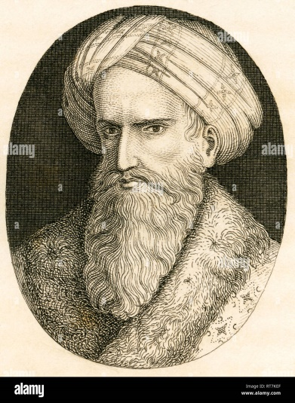

Part one
A/Reading Comprehension
Activity 01: Read the text and answer the questions (02pts)
- What or who do the words in bold type refer to:
Who ………………………… His ………………………………..
- When did Harun al-Rashid became Caliph?
………………………………………………………………………………….
Activity 02: Read the text again and fill in the table. (03pts)
Real name | Occupation | Date of birth | Place of birth | Date of death | Place of death

Activity 03: Find in the text : (02pts)
Synonyms to:
Amazing = ……………………….. (§2) viewed = …………..………… (§ 2)
Opposites to:
Later ≠……………………….. (§2) False ≠ ………………………. (§2)
B/Mastery of Language
Activity 01: Finish the following table: (03pts)
Adjectives | Comparative of superiority
- Big  - ………………………………  - Expensive | - ………………………….  - Easier than  - .........................................

Activity 02: Fill in the gaps with the appropriate connector (cause/result): (02pts)
- Laarbi Ben Mhidi was killed ………………………………..he refused to surrender.
- Mark wanted to see the Eiffel Tower, ……………………………..he travelled to Paris.
Activity 03: Circle the silent letter in the following words: (02pts)
Often - Lamb - Half - Write
Part two
Situation of Integration: (06pts)
Djamila Bouhired is one of the greatest figures in Algerian history.
Your teacher asked to write a short biography about this outstanding figure to post it on your school blog. Use the information bellow to help you.
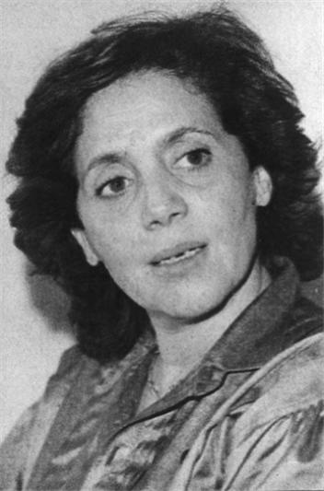
Full name: Djamila Bouhired
Date and place of birth: June 1935- Algiers - Algeria
Family: Middle class family, Tunisian mother, Algerian father
Occupation: Algerian militant, nationalist
Life events:
- (to join) the Algerian National Front (FLN)
while ( to be) a student
- (to capture) by the French army (April 1957)
- (to face) torture for 17 days in front of her mother
but (not/ to stop) fighting for her country
- (to bomb) a café killing 11 French people (1957)
- A film by the Egyptian director ‘Yusuf Chahin’
(to tell) her story (1958)

………………………………………………………………………………………………………………………………………………………………………………………………………………………………………………………………………………………………………………………………………………………………………………………………………………………………………………………………………………………………………………………………………………………………………………………………………………………………………………………………………………………………………………………………………………………………………………………………………………………………………………………………………………………………………………………………………………………………………………………………

