13 | 12 | 11 | 10
.......................................................................................................................................................................................................................................................................................................................................................
17 | 16 | 15 | 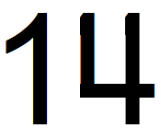
..............................................................................................................................................................................................................................................................................................................................................................................................................

21 | 20 | 19 | 18
.......................................................................................................................................................................................................................................................................................................................................................
25 | 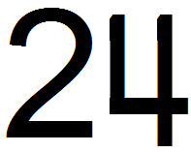 | 23 | 22
...........................................................................................................................................................................................................................................................................................................................................................................
29 | 28 | 27 | 26
.......................................................................................................................................................................................................................................................................................................................................................
33 | 32 | 31 | 30
...........................................................................................................................................................................................................................................................................................................................................................................
37 | 36 | 35 | 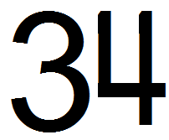
.......................................................................................................................................................................................................................................................................................................................................................
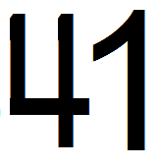 |  | 39 | 38
...........................................................................................................................................................................................................................................................................................................................................................................
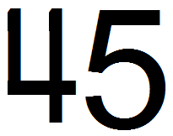 | 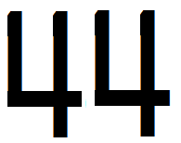 | 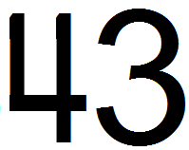 | 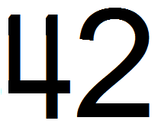
.........................................................................................................................................................................................................................................................................................................................................................................................................
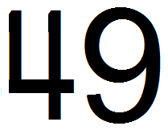 | 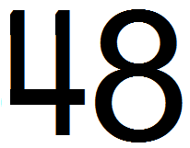 | 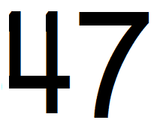 | 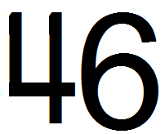
...........................................................................................................................................................................................................................................................................................................................................................................
53 | 52 | 51 | 50
.......................................................................................................................................................................................................................................................................................................................................................
57 | 56 | 55 | 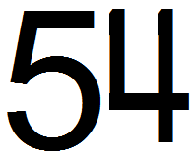
.............................................................................................................................................................................................................................................................................................................................................................................
61 | 60 | 59 | 58
.......................................................................................................................................................................................................................................................................................................................................................
65 | 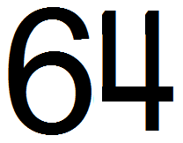 | 63 | 62
..............................................................................................................................................................................................................................................................................................................................................................................
69 | 68 | 67 | 66
.......................................................................................................................................................................................................................................................................................................................................................
73 | 72 | 71 | 70
...............................................................................................................................................................................................................................................................................................................................................................................
77 | 76 | 75 | 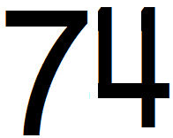
.......................................................................................................................................................................................................................................................................................................................................................
81 | 80 | 79 | 78
............................................................................................................................................................................................................................................................................................................................................................................
85 | 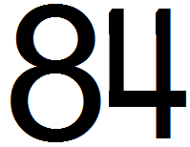 | 83 | 82
.......................................................................................................................................................................................................................................................................................................................................................
89 | 88 | 87 | 86
...........................................................................................................................................................................................................................................................................................................................................................................
93 | 92 | 91 | 90
.......................................................................................................................................................................................................................................................................................................................................................
97 | 96 | 95 | 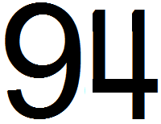
............................................................................................................................................................................................................................................................................................................................................................................
100 | 99 | 98
.............................................................................................................................................................................................................................................................................................................................................................................................

