Toumi Saci M. School School year: 2022/2023

Level: 2 MS | The English Final Exam | Duration:1h30
Next summer holiday, Karim and I will visit Setif, it’s a nice city in the east of Algeria. We’ll travel by bus and we will stay in a hotel. First, on Friday we will make a look around the city and take some photos.Then, we will visit Djmila, on Saturday. It’s a small city full of Roman ruins. After that, on Sunday we will go to the park in which there are a lot of games and cute animals. Finally, on Monday we will do some shopping in the big mall and buy some souvenirs and we will come back home in the afternoon.

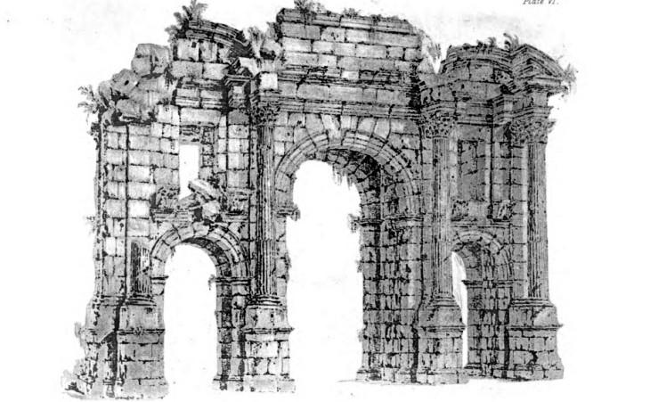

Part one.
I/ Reading comprehension.
Task one: Read the text and write “true” or “false”. (3pts )
1 - Karim will visit Setif with his family. ……………….

2- Setif is in the east of Tunisia. ……………………

3- They will visit Djmila On Saturday …………………….

Task two: Read again the text and answer the questions below. (2pts)
- Where will Karim and his friend go next summer?
........................................................................................................................................................
- Will they travel by bus ? ................................................................................................................................................
Task three: I choose the correct answer (2pts)

1 – Karim is going to go to: a) Timgad b) Tassily c) Djmila
2 – He will go back home in the : a) morning b) night c) afternoon

Page 1/2

I/ Mastery of language
Task one: I name the following weather predictions .(3 pts) ( rainy , cloudy , sunny )

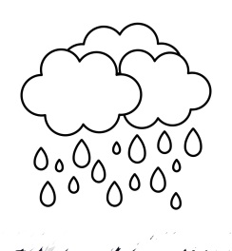


1 - …………….. 2 - ……………… 3 - …………………

Task two: I reorder the following words to get coherent sentences . (02 pts)
- go/ travel/ She/ will / to/ next/ Annaba/ summer/./ …………………………………
- going/ am / I / visit / fiends / today/ to/ my/./ …………………………………………

Task three: Classify these words according to the pronunciation of the sound: (2pts)
father – month – weather- Thursday

………………………………. ………………………………. | Three [θ]
  mother [ð]
 | …………………………………… …………………………………..

Part two. I learn to Integrate (6 pts)
complete Sara’s plans with ( Oran – hotel – places – will not – holidays – car )

Next ………….., Sara will visit ……….... She ……….. go there alone. She will go with her family. They will not travel by bus , because they have a nice …... They will visit many nice…………….such as historic sites and monuments. They will stay in a ……… because her father rent a house.

Good Luck

Pages 2/2

